After the data has been stored in your table, **provide SQL and the result** for the following queries:

1. Provide a list of laptops which include information about Average Battery Life (in hours). The result should display laptop number, item model number, operating system and average battery life.
2. Provide a report which lists all laptops that have their item weight greater than 1 kg. The result should display laptop number, product description, price and item weight.
3. Provide a report which lists all laptops that have their screen resolutions of at least a full HD. A full HD screen resolution or better must have at least 1920 pixels in length and 1080 pixels in width. The result should show laptop number, ram capacity, and the screen size (in pixels) in the numerical format of **L x W** (e.g. **1920 x 1080)**.
4. Provide a report on laptops whose batteries are not a combination of “battery **type”** lithium and “battery **charge technology”** ion. The result should show laptop number, item model number, **battery type** (e.g., lithium, nickel metal hydride (NiMH), nickel cadmium (NiCad)) and **battery charge technology** (e.g., metal, polymer or ion for lithium batteries and perhaps, **other** for other battery types) **[20 marks].**

Answer a: (1.sql)

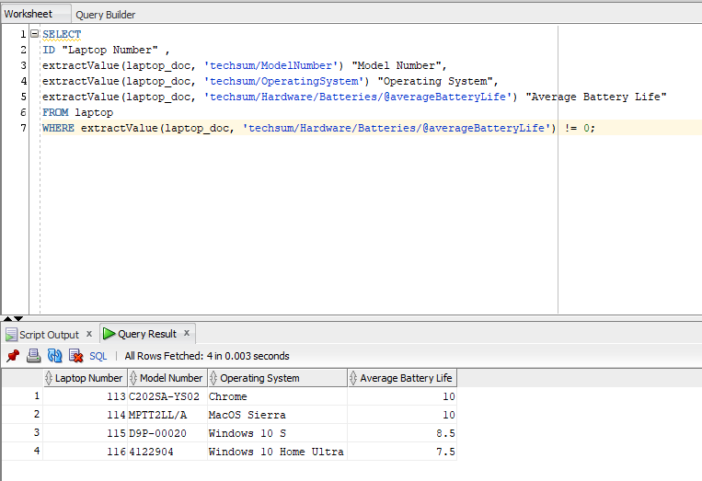

Answer b: (2.sql)

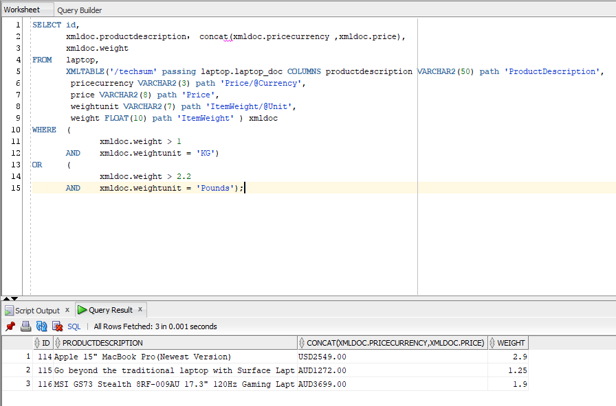

Answer c: (3.sql)

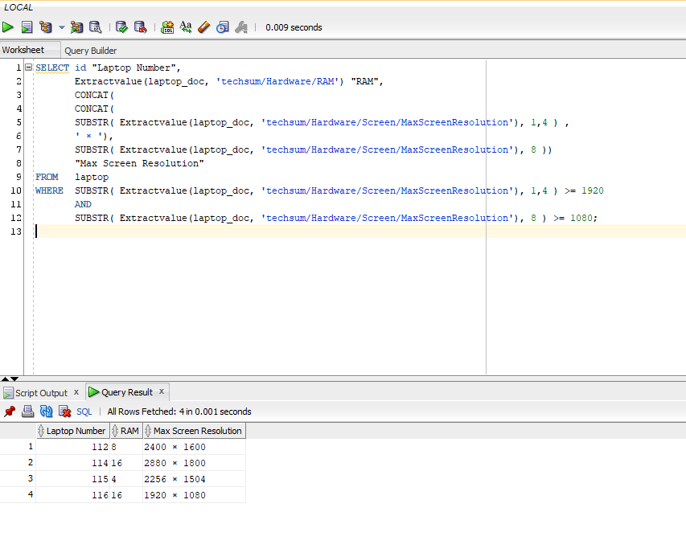

Answer d: (4.sql)

